Steps / Navigation | SYSTEM SCREENSHOTS | COMMENTS / REMARKS
Click on Menu option:  Records > Officials >  Action – Select Workflow (Dentons)  Click on:  + Auditor | 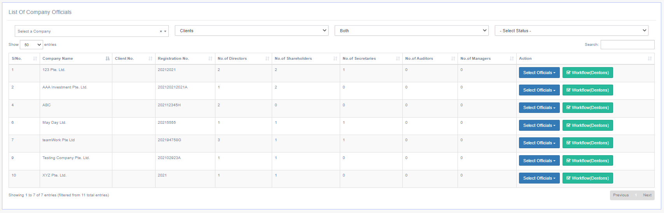  
Auditor’s Listing Page  Click on:  + Multiple Removal  This option removes multiple appointed Auditor within the company. | 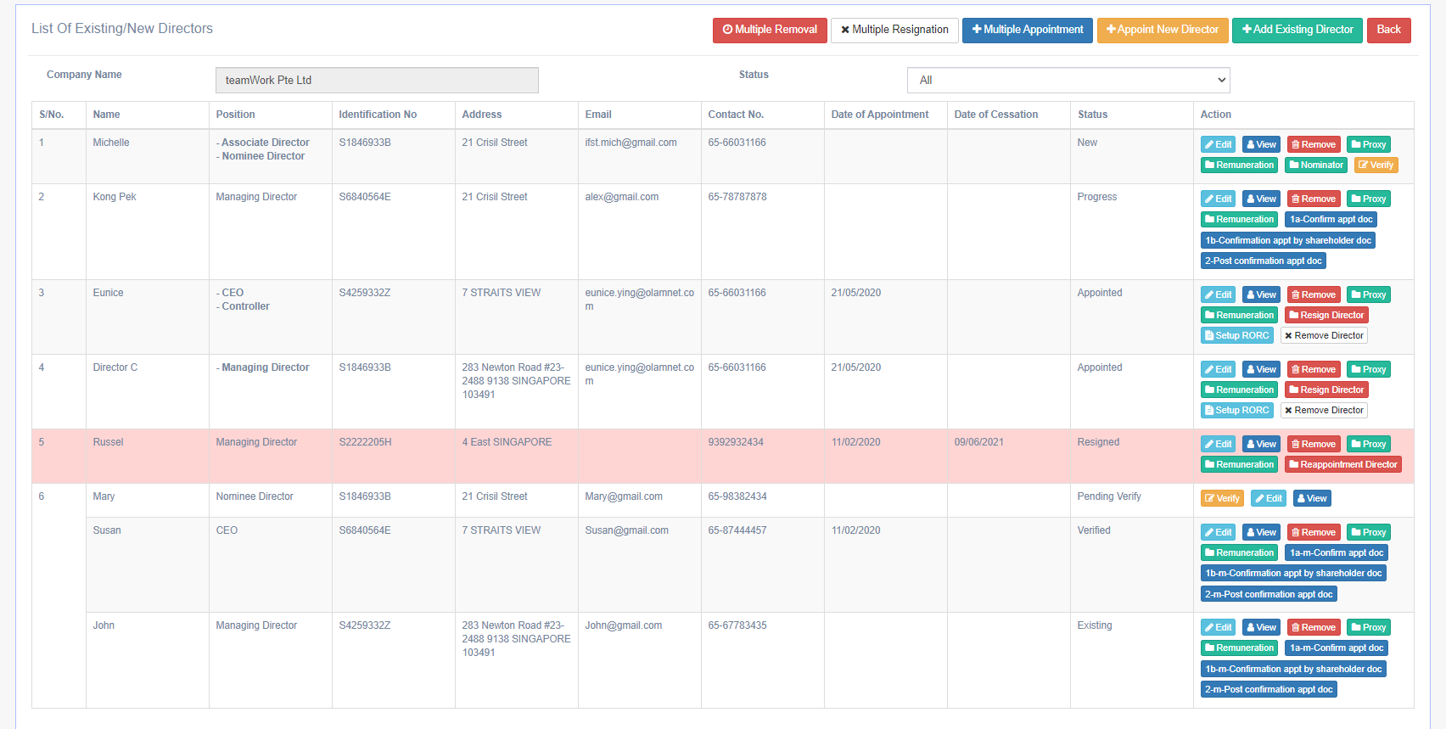
Multiple Resign Auditor Preview Page  Check on the respective Auditor to be resigned.  Click on:  + Proceed | 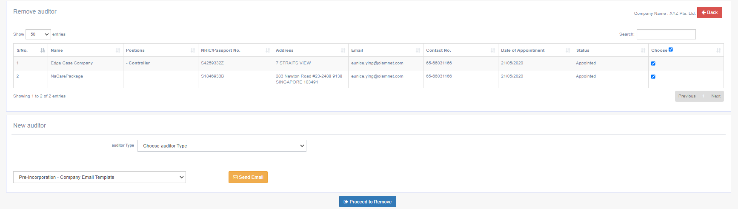 | Meeting Notes 2/11:  To provide provision for appointing new auditor – Yes / No before selection mandatory in this step.
Multiple Resign Auditor Preview Page  System will show the respective Auditor in rows, expand the section to preview the Auditor’s details  Click on:  + 1. Pre-Collection | 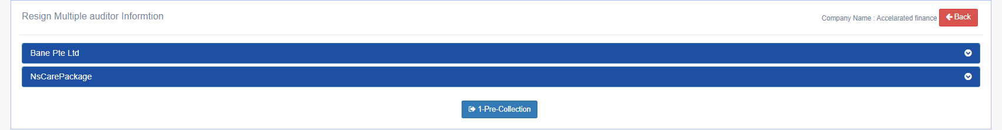  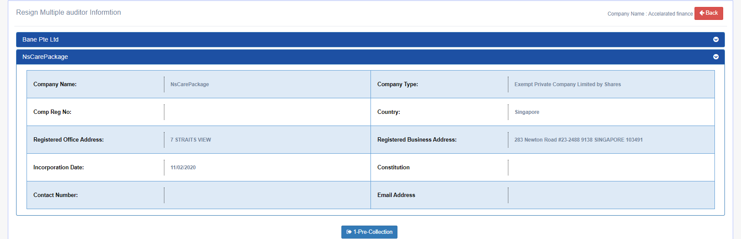
1 M Pre-Collection Page  Click on Generate @ Document Information Section to add templates into  Default Generated Documents Section  *Note that these templates are dummy templates.  Only the naming follows the given excel from Dentons  Generated Document @ Default Generated Documents Section can be previewed / deleted  Attach Custom Documents @ Add Custom Document Section  Click on + to attach more custom documents  Select Email Template (Pre-configured in Settings) to be sent out to Clients  Click on:  Submit & Email | 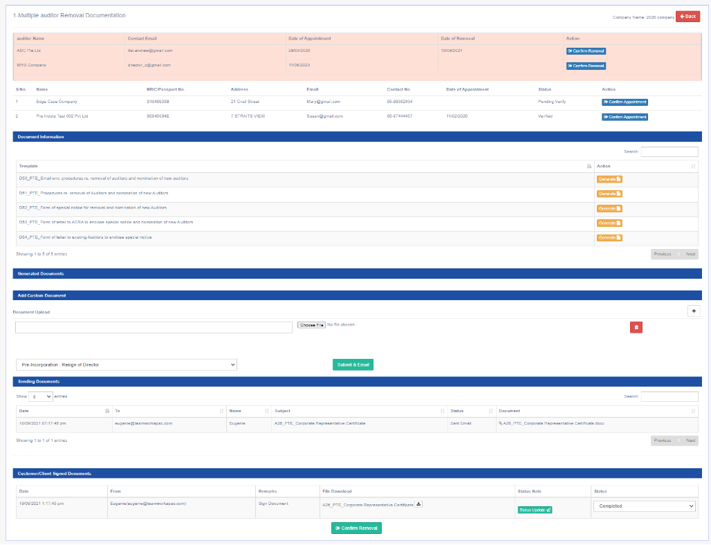
Generate Documents Send Email Page  Email Preview from the defaulted chosen template with be displayed along with contact person email.  Email content can be amended at this stage before email is sent out to contact person  Click on:  Send & Submit | 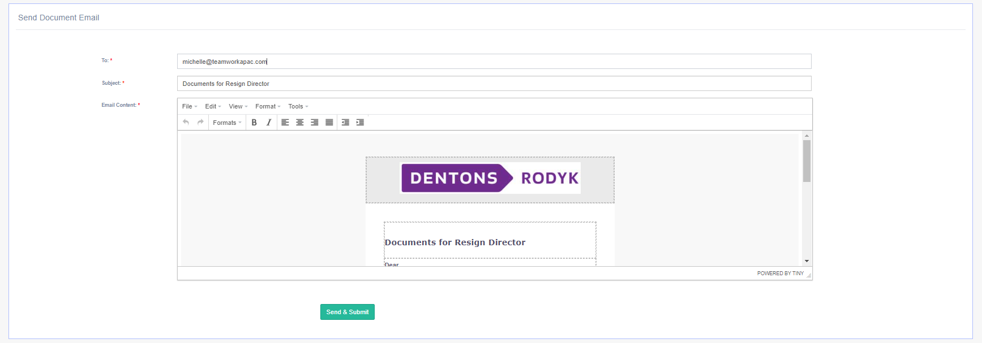
Denton’s Client Receive Email in their Inbox  Click on:  Update Document Link | 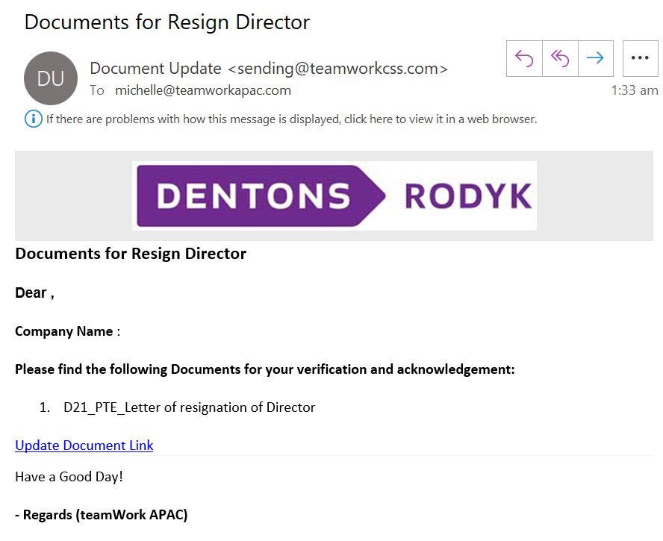
Denton’s Client Open URL  Official Download Documents Section:  Will display documents attached by Dentons:  - Generated Documents  - Custom Documents  Clients can upload the signed copies of the documents using the Upload section with the Upload Button  Your Uploaded Document Section:  Will display all the uploaded documents from client with Status: pending (just uploaded) | 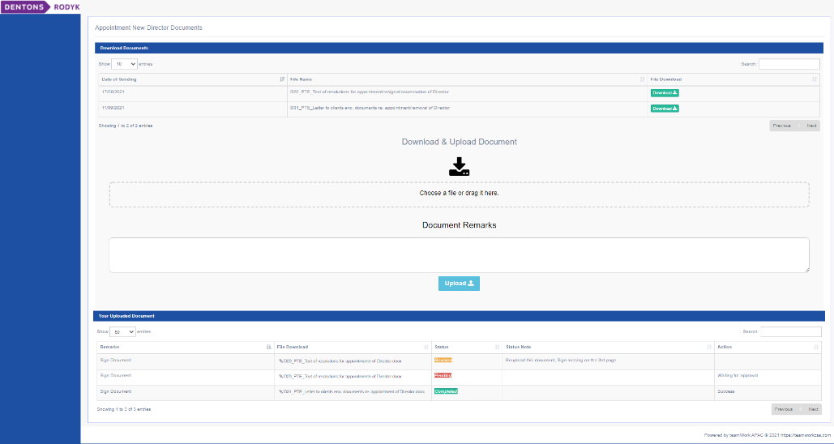
Dentons Receive Client Signed Document Updates

Click on:
Multiple Removal
1 M Pre-Collection Page

Click on Generate @ Document Information Section to add templates into
Default Generated Documents Section
*Note that these templates are dummy templates.
Only the naming follows the given excel from Dentons

Generated Document @ Default Generated Documents Section can be previewed / deleted
Attach Custom Documents @ Add Custom Document Section
Click on + to attach more custom documents

Select Email Template (Pre-configured in Settings) to be sent out to Clients

Click on:
Submit & Email
Denton’s Client Receive Email in their Inbox (Revision)

Click on:
Update Document Link
Denton’s Client Open URL  Official Download Documents Section:  Will display documents attached by Dentons:  - Generated Documents  - Custom Documents  Clients can upload the signed copies of the documents using the Upload section with the Upload Button  Your Uploaded Document Section:  Will display all the uploaded documents from client with Status: pending (Just uploaded)  Status: revision (Pending Client’s Action, Reupload Required)  Status: completed (No Action Required) | 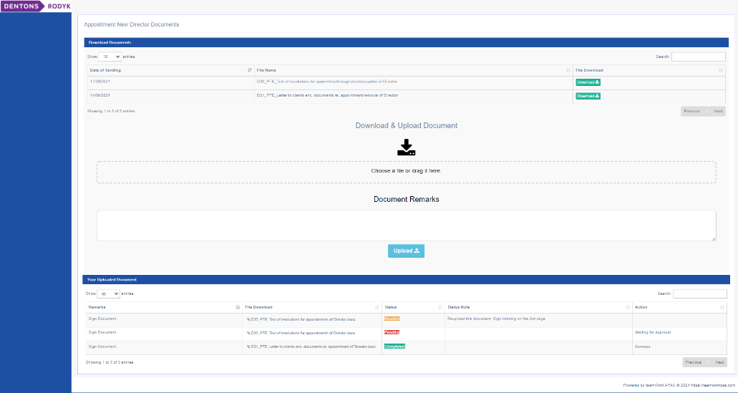
Dentons Receive Client Document (Revision) Updates

Click on:
Multiple Removal
1 M Pre-Collection Page  Top section:  Display of the auditor to be removed along with new auditor to be appointed.  Appointment and Removal Dates of new Auditors can be updated above  Official Uploaded Documents Section:  Will display the email correspondence sent by Dentons to the clients  Customer/Client Signed Documents Section:  Will display the documents uploaded by the clients for Dentons  Dentons can update the Status Update to inform client on the missing information.  E.g. Page 2 signature missing  Dentons can update the  Status – Revision (if they require Client’s action to reupload another copy of the document)  Status – Revision pending (Dentons to act on the revised document sent back by Client)  Status – Completed (No further Action Required)  When all documents Status are Completed,  Confirm Removal Button will appear  Click on:  Confirm Removal  Update the Removal Dates  Click on:  Submit | 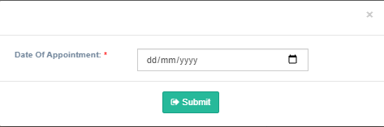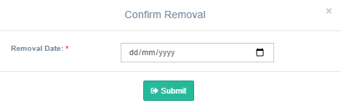
2 M Post Collection Page  Click on Generate @ Document Information Section to add templates into  Default Generated Documents Section  *Note that these templates are dummy templates.  Only the naming follows the given excel from Dentons  Generated Document @ Default Generated Documents Section can be previewed / deleted  Attach Custom Documents @ Add Custom Document Section  Click on + to attach more custom documents  Select Email Template (Pre-configured in Settings) to be sent out to Clients  Click on:  Submit & Email | 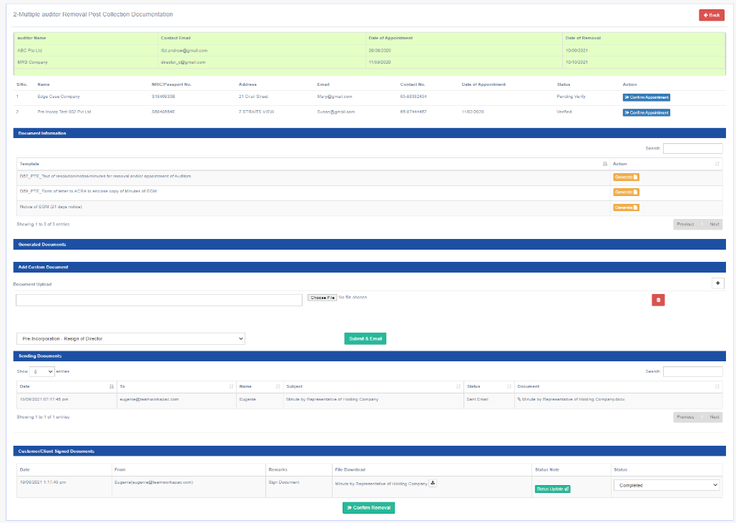
Generate Documents Send Email Page

Email Preview from the defaulted chosen template with be displayed along with contact person email.

Email content can be amended at this stage before email is sent out to contact person

Click on:
Send & Submit
Denton’s Client Receive Email in their Inbox

Click on:
Update Document Link
Denton’s Client Open URL

Official Download Documents Section:
Will display documents attached by Dentons:
- Generated Documents
- Custom Documents

Clients can upload the signed copies of the documents using the Upload section with the Upload Button

Your Uploaded Document Section:
Will display all the uploaded documents from client with Status: pending (just uploaded)
Dentons Receive Client Signed Document Updates

Click on:
Multiple Removal
2 M Post-Collection Page

Click on Generate @ Document Information Section to add templates into
Default Generated Documents Section
*Note that these templates are dummy templates.
Only the naming follows the given excel from Dentons

Generated Document @ Default Generated Documents Section can be previewed / deleted
Attach Custom Documents @ Add Custom Document Section
Click on + to attach more custom documents

Select Email Template (Pre-configured in Settings) to be sent out to Clients

Click on:
Submit & Email
Denton’s Client Receive Email in their Inbox (Revision)

Click on:
Update Document Link
Denton’s Client Open URL

Official Download Documents Section:
Will display documents attached by Dentons:
- Generated Documents
- Custom Documents

Clients can upload the signed copies of the documents using the Upload section with the Upload Button

Your Uploaded Document Section:
Will display all the uploaded documents from client with Status: pending (Just uploaded)
Status: revision (Pending Client’s Action, Reupload Required)
Status: completed (No Action Required)
Dentons Receive Client Document (Revision) Updates

Click on:
Multiple Removal
2 M Post Collection Page

Top section:
Display of the auditor to be removed along with new auditor to be appointed.
Appointment and Removal Dates of new Auditors can be updated above

Official Uploaded Documents Section:
Will display the email correspondence sent by Dentons to the clients

Customer/Client Signed Documents Section:
Will display the documents uploaded by the clients for Dentons

Dentons can update the Status Update to inform client on the missing information.
E.g. Page 2 signature missing

Dentons can update the
Status – Revision (if they require Client’s action to reupload another copy of the document)
Status – Revision pending (Dentons to act on the revised document sent back by Client)
Status – Completed (No further Action Required)

When all documents Status are Completed,
Confirm Removal Button will appear

Click on:
Confirm Removal
3 M Final-Collection Page  Click on Generate @ Document Information Section to add templates into  Default Generated Documents Section  *Note that these templates are dummy templates.  Only the naming follows the given excel from Dentons  Generated Document @ Default Generated Documents Section can be previewed / deleted  Attach Custom Documents @ Add Custom Document Section  Click on + to attach more custom documents  Select Email Template (Pre-configured in Settings) to be sent out to Clients  Click on:  Submit & Email | 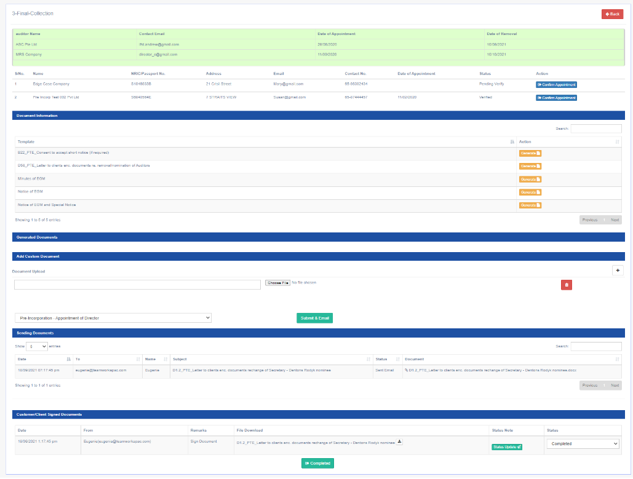
Generate Documents Send Email Page

Email Preview from the defaulted chosen template with be displayed along with contact person email.

Email content can be amended at this stage before email is sent out to contact person

Click on:
Send & Submit
Denton’s Client Receive Email in their Inbox

Click on:
Update Document Link
Denton’s Client Open URL

Official Download Documents Section:
Will display documents attached by Dentons:
- Generated Documents
- Custom Documents

Clients can upload the signed copies of the documents using the Upload section with the Upload Button

Your Uploaded Document Section:
Will display all the uploaded documents from client with Status: pending (just uploaded)
Dentons Receive Client Signed Document Updates

Click on:
Multiple Removal
3 M Final-Collection Page

Click on Generate @ Document Information Section to add templates into
Default Generated Documents Section
*Note that these templates are dummy templates.
Only the naming follows the given excel from Dentons

Generated Document @ Default Generated Documents Section can be previewed / deleted
Attach Custom Documents @ Add Custom Document Section
Click on + to attach more custom documents

Select Email Template (Pre-configured in Settings) to be sent out to Clients

Click on:
Submit & Email
Denton’s Client Receive Email in their Inbox (Revision)

Click on:
Update Document Link
Denton’s Client Open URL

Official Download Documents Section:
Will display documents attached by Dentons:
- Generated Documents
- Custom Documents

Clients can upload the signed copies of the documents using the Upload section with the Upload Button

Your Uploaded Document Section:
Will display all the uploaded documents from client with Status: pending (Just uploaded)
Status: revision (Pending Client’s Action, Reupload Required)
Status: completed (No Action Required)
Dentons Receive Client Document (Revision) Updates

Click on:
Multiple Removal
3 M Final-Collection Page

Top section:
Display of the auditor to be removed along with new auditor to be appointed.
Appointment and Removal Dates of new Auditors can be updated above

Official Uploaded Documents Section:
Will display the email correspondence sent by Dentons to the clients

Customer/Client Signed Documents Section:
Will display the documents uploaded by the clients for Dentons

Dentons can update the Status Update to inform client on the missing information.
E.g. Page 2 signature missing

Dentons can update the
Status – Revision (if they require Client’s action to reupload another copy of the document)
Status – Revision pending (Dentons to act on the revised document sent back by Client)
Status – Completed (No further Action Required)

When all documents Status are Completed,
Completed Button will appear

Click on:
Completed
Auditor’s Listing Page

Auditor will appear in the listing table with Status – Resigned and New Auditor will have Status – Appointed

